Chunking Strategy Evaluation: Detailed Technical Report

The first step for a complete RAG project — find the best chunking strategy for your document domain before tuning anything downstream.
Field | Value
Step | First step of a complete RAG project: chunking
Status | Complete — 2 runs finished
Document domain | Annual reports (P&G Annual Report 2025)
Golden dataset | 50 questions (data/pg_2025_gold_evaluation_dataset.json)
Run 1 | Substring-match evaluation (2026-09-10)
Run 2 | Substring + semantic-similarity evaluation
Winner (semantic) | recursive — semantic Recall@3 = 0.58
Winner (substring) | fixed_size — Recall@3 = 0.38
Best value | recursive — top quality at 2nd-lowest cost ($0.0035)

Table of Contents
- Objective & Scope
- Document Domain
- Golden Dataset
- Chunk Data Structure
- Chunking Strategies
- Azure Services & Technical Aspects
- Experiment Pipeline
- Evaluation Methodology
- Results — Run 1 (Substring Match)
- Results — Run 2 (Substring + Semantic)
- Comparative Analysis — Run 1 vs Run 2
- Cost & Latency Analysis
- Recommendation
- Findings & Limitations
- Reproducibility & References

1. Objective & Scope
Goal: Determine which chunking strategy produces the best retrieval quality for annual-report documents, so that every later step of the RAG project (embeddings → retrieval → generation → optimization) builds on the right foundation.
Why chunking first: Chunking is the earliest irreversible decision in a RAG pipeline. A bad split permanently destroys context (e.g. a table row separated from its header) that no embedding model or reranker can recover. All later experiments therefore fix this step's winner and vary only one factor at a time.
Why annual reports: dense financial tables where numbers differ only by column position (84,284 vs 84,039), mixed prose/statements/footnotes, and questions spanning single-cell lookup to multi-step reasoning.
Scope: This step evaluates retrieval only (no LLM generation). Retrieval = embed 50 golden questions → top-5 vector search → score against ground truth. Generation quality (faithfulness, relevancy) is evaluated in a later step.

2. Document Domain
Attribute | Value
Source | data/raw_pdf/P&G_AnnualReport.pdf (Procter & Gamble, FY2025) — 4.28 MB, 301 pages
Processed form | data/markdown/P&G_AnnualReport.md (0.36 MB) via pymupdf4llm (src/utils/pdf_to_markdown.py)
Loader | src/utils/document_loader.py → load_all_documents(use_markdown=True) prefers markdown, splits on headings into "page-like" sections

3. Golden Dataset
Location: data/pg_2025_gold_evaluation_dataset.json · Builder: buildgolddataset.py (curated list → JSON) · Size: 50 entries (q001–q050)

3.1 Schema (8 fields per entry)

Field | Description
id / question | Question ID / natural-language question asked to the retriever
ground_truth_answer | Human-verified answer (reserved for generation evaluation in a later step)
supporting_text | Evidence span the retrieved chunk must contain / resemble — the retrieval ground truth
source / source_span | {document, page, section} provenance + {page, start_text, end_text} span
question_type / difficulty | One of 13 types (§3.2) / easy / medium / hard

{
"id": "q001",
"question": "What were P&G's net sales in fiscal 2025?",
"ground_truth_answer": "$84.3 billion",
"supporting_text": "Net sales $ 84,284 $ 84,039 — %",
"source": {"document": "P&G_AnnualReport.pdf", "page": 19, "section": "Summary of 2025 Results"},
"source_span": {"page": 19, "start_text": "Net sales", "end_text": "$ 84,284 $ 84,039 — %"},
"question_type": "fact",
"difficulty": "easy"
}

3.2 Question-type taxonomy (measured from the dataset file)

Type | n | Tests | Sample
fact | 19 | Single-figure lookup | P&G's net sales in FY2025?
cause_effect | 6 | Reason behind a result | Why did operating income rise 10%?
context | 5 | Synthesized narrative | Major challenges in FY2025?
table_lookup | 5 | Cell-level extraction | Beauty's net sales?
comparison | 4 | Cross-segment contrast | North America vs European Focus markets?
multi_sentence | 2 | Answer spans sentences | Cash returned to shareholders?
list | 2 | Enumerated sets | Daily-use categories in focused portfolio?
boundary_sensitive | 2 | Exact span edges | Why Fabric & Home Care sales flat?
5 singletons | 1 ea | definition_and_fact, multi_concept, multi_factor, structured_data, definition_and_multi_step_reasoning | e.g. factors behind $14.6B free cash flow?
Stats: difficulty 24 easy / 14 medium / 12 hard; avg lengths — question 65, evidence 106, answer 63 chars; all questions draw from 6 PDF pages (19, 22–24, 43–44): a precision test, not a coverage test.

4. Chunk Data Structure
All strategies emit the same dataclass (src/chunking/base.py), so embedding → indexing → evaluation is strategy-agnostic:
@dataclass
class Chunk:
id: str # fixed_ / rec_ / sem_ / md_ / pc_ + source_page_index
text: str
source: str
page: int # heading ordinal, NOT pdf page (see §2)
section: str = "" # heading text (populated by markdown_aware only)
chunk_index: int = 0
metadata: dict = field(default_factory=dict)

Index IDs are sanitized (re.sub(r'[^a-zA-Z0-9_=-]', '_', id)) for Azure AI Search key constraints. Token counting uses tiktoken cl100k_base everywhere (chunk stats + cost accounting). parent_child stores {parent_text, parent_index} in metadata so the full parent can be returned as LLM context at generation time.

5. Chunking Strategies
Same input (markdown sections), same downstream pipeline — only the splitter differs.
fixed_size (fixed_size.py): pure token-window slicing — encode with tiktoken, slide a 512-token window with 50-token overlap. Deterministic, O(n), no external calls; cuts mid-sentence/mid-table. → 405 chunks, avg 225.0 tokens.
recursive (recursive.py): LangChain RecursiveCharacterTextSplitter, separators ["\n\n", "\n", ". ", " ", ""], chunk_size=512, overlap=50 — but length_function=len counts characters, not tokens, so "512" ≈ ~128 tokens of English. Same nominal config as fixed_size, very different granularity. → 1,269 chunks, avg 68.4 tokens.
semantic (semantic.py): LangChain SemanticChunker over AzureOpenAIEmbeddings, percentile breakpoint 75.0; splits where inter-sentence similarity drops. Requires embedding calls at chunk time — measured 126 s chunking vs <1 s for all others. → 742 chunks, avg 115.5 tokens.
markdown_aware (markdown_aware.py): custom regex on headings ^(#{1,6})\s+(.+)$; one chunk per section, tables kept whole, oversize sections (>1024 chars) sub-split on paragraphs. Fastest chunker (12 ms), uneven sizes. → 602 chunks, avg 142.6 tokens.
parent_child (parent_child.py): two-level split — parents 1024 chars / overlap 0 → children 256 chars / overlap 30. Child text is embedded for retrieval; parent rides along in metadata. Highest-resolution index. → 2,179 chunks, avg 41.4 tokens.
Strategy | Unit | Size / overlap | Chunks | Avg tokens
fixed_size | tokens | 512 / 50 | 405 | 225.0
recursive | chars | 512 / 50 | 1,269 | 68.4
semantic | sentences | p75 breakpoint | 742 | 115.5
markdown_aware | chars | 1024 max | 602 | 142.6
parent_child | chars | 1024 / 256, ov 0 / 30 | 2,179 | 41.4

6. Azure Services & Technical Aspects

Service | Setup | Role in this step
Azure OpenAI | rag-evaluation-optimization.cognitiveservices.azure.com, API 2023-05-15, text-embedding-3-small (1536-d, batch 100), cosine via numpy (src/embeddings/azure_openai.py) | chunk, query, and eval embeddings; gpt-4o provisioned for generation later
Azure AI Search | rag-experimentation-vector-db.search.windows.net, index rag-evaluation-index, HNSW (default profile) | vector index + top-5 retrieval (src/retrieval/azure_ai_search.py)

Index fields: id (key) · text (searchable) · source, page, strategy (filterable — each run isolated via strategy eq '<name>_v2') · section (searchable) · embedding (1536-d vector). Retrieval is pure vector (search_text=None, VectorizedQuery k=5); uploads in batches of 100; each script deletes + recreates the index, then cleans up. bm25_search() / hybrid_search() exist for a later retrieval-comparison step.
Portal telemetry (Run 1 screenshots): AOAI 1.03M input tokens, 530 requests, 269.78 ms avg latency; Search 1.26 queries/s, 13.85 ms latency, 6 MB vector storage.
Pricing applied: embeddings $0.02 / 1M tokens (CostTracker: tokens/1e6 × 0.02). Reference: embedding-large (3072-d) ≈ $0.13/1M; GPT-4o $2.50 in / $10.00 out; mini $0.15 / $0.60.
Shared constants: tokenizer tiktoken cl100k_base · top-k = 5 (RETRIEVAL_TOP_K) · metric cutoffs k = 1/3/5 · semantic threshold cosine ≥ 0.6.

7. Experiment Pipeline
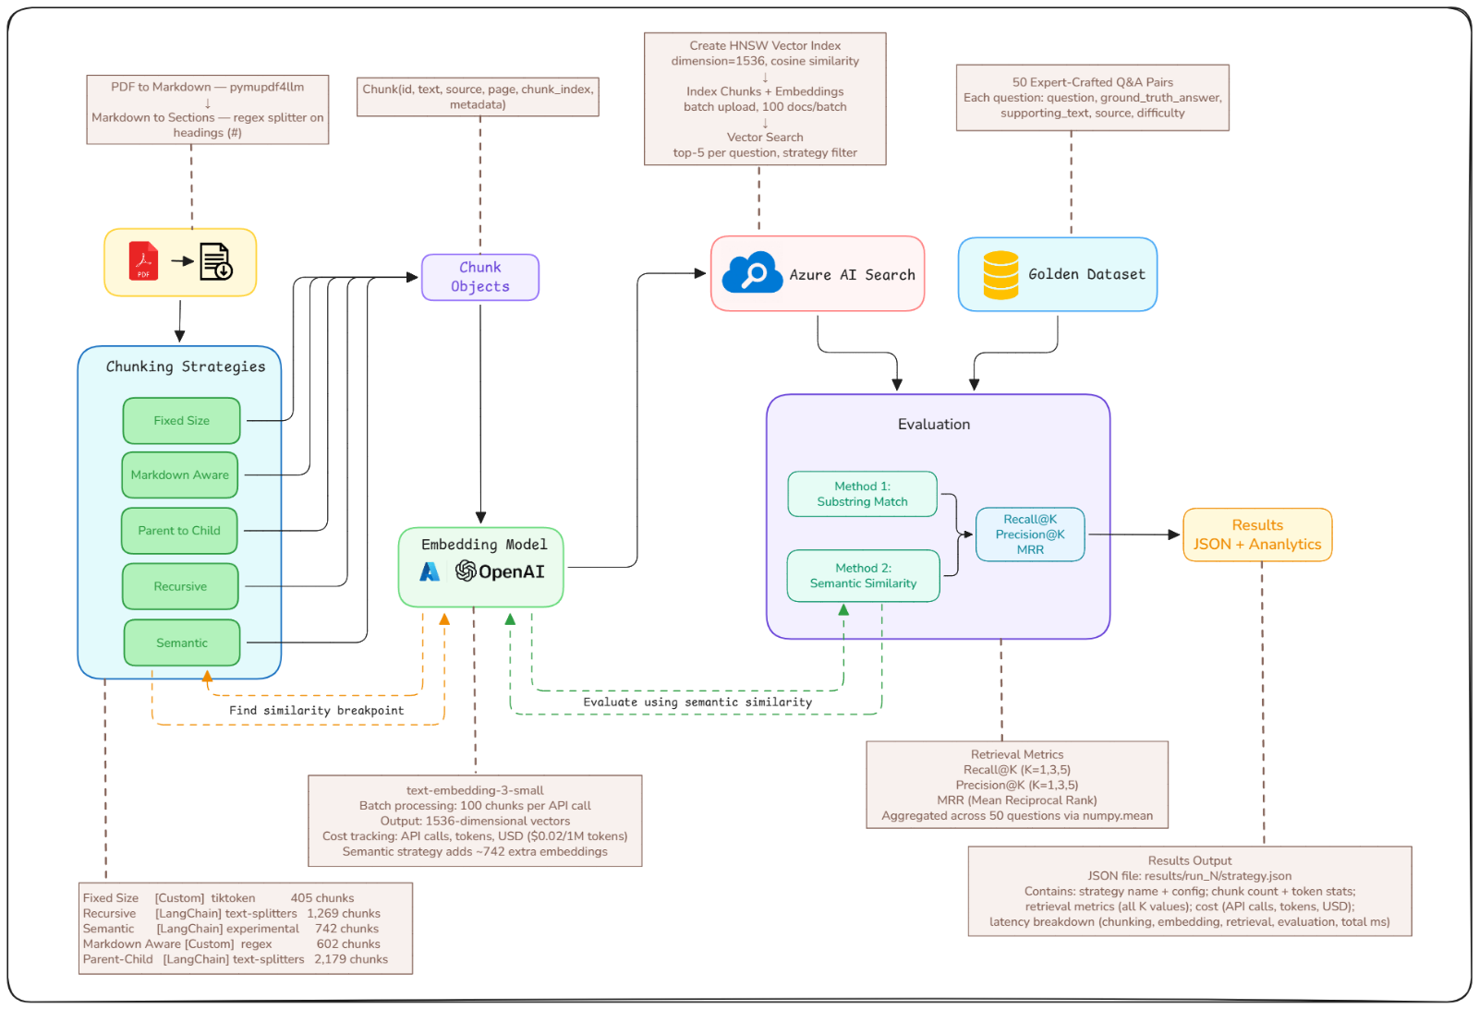

8. Evaluation Methodology
Substring (Run 1, retrieval_metrics.py): supporting_text.lower() in chunk.text.lower() — binary, no partial credit. Weaknesses: markdown artifacts break matches, paraphrases score 0, 90% overlap = 0%.
Semantic (Run 2, semantic_relevance.py): embed evidence + retrieved chunks with text-embedding-3-small; relevant iff cosine ≥ 0.6. Supports pre-embedded once (1 batch); each retrieved chunk embedded individually (~650 calls/strategy — the reason Run 2 costs more). avg_similarity (mean cosine over top-5) adds a threshold-free graded signal.
Metric | Rule
Recall@k | 1.0 if any top-k chunk relevant, else 0 (averaged over 50 Qs)
Precision@k | fraction of top-k relevant (averaged)
MRR | mean of 1/rank of first relevant hit (0 if none)
semantic_* | same rules with cosine ≥ 0.6 as relevance

Worked example — "What were P&G's net sales in fiscal 2025?": a 225-token fixed_size chunk containing the table row → substring HIT. A 41-token parent_child chunk reading "Net sales increased $245M to $84.3B…" → substring MISS, cosine ≈ 0.8 → semantic HIT. This one mechanism explains the ranking flip in §11.

9. Results — Run 1 (Substring Match)

Strategy | R@1 | R@3 | R@5 | P@3 | MRR | Cost | Time
fixed_size | 0.22 | 0.38 | 0.38 | 0.127 | 0.293 | $0.0018 | 235 s
markdown_aware | 0.20 | 0.34 | 0.36 | 0.113 | 0.264 | $0.0017 | 190 s
semantic | 0.12 | 0.28 | 0.30 | 0.093 | 0.194 | $0.0017 | 300 s
recursive | 0.14 | 0.26 | 0.34 | 0.087 | 0.216 | $0.0017 | 214 s
parent_child | 0.14 | 0.22 | 0.22 | 0.073 | 0.180 | $0.0018 | 240 s
Read: Recall@3 strictly decreases with chunk size (225→38%, 143→34%, 116→28%, 68→26%, 41→22%) — big chunks are likelier to contain the exact evidence string; small chunks split evidence (avg 106, up to 284 chars) across boundaries. Indexing ≈ 86–91K tokens per strategy → cost flat (~$0.0017). Retrieval (~3.1 s/query) dominates runtime.

10. Results — Run 2 (Substring + Semantic)

Substring columns reproduce Run 1 exactly — the pipeline is deterministic; Run 2 is a strict superset. Semantic results (threshold 0.6):
Strategy | Sem R@1 | Sem R@3 | Sem R@5 | Sem P@3 | Sem MRR | Avg sim
recursive | 0.38 | 0.58 | 0.64 | 0.3400 | 0.4873 | 0.5488
parent_child | 0.36 | 0.56 | 0.62 | 0.3400 | 0.4673 | 0.5502
semantic | 0.36 | 0.56 | 0.58 | 0.3467 | 0.4550 | 0.5315
markdown_aware | 0.42 | 0.52 | 0.58 | 0.3067 | 0.4753 | 0.5341
fixed_size | 0.26 | 0.42 | 0.44 | 0.2333 | 0.3350 | 0.5071

Cost (indexing + eval embeddings):
Strategy | API calls | Tokens | Cost | / question
parent_child | 650 | 142,050 | $0.0028 | $0.000057
recursive | 646 | 177,207 | $0.0035 | $0.000071
markdown_aware | 655 | 276,347 | $0.0055 | $0.000111
semantic | 652 | 276,626 | $0.0055 | $0.000111
fixed_size | 678 | 416,977 | $0.0083 | $0.000167
Latency (total 1,015–1,343 s): evaluation sweeps 814–878 s (~70–80% of wall clock); retrieval flat ~155 s; embedding 13–33 s; chunking ≈ 0 except semantic (126 s) vs markdown_aware (12 ms). Fastest: markdown_aware (1,015 s). Slowest: parent_child (1,343 s, +32%).

11. Comparative Analysis — Run 1 vs Run 2
Strategy | Substring R@3 | Semantic R@3 | Δ
fixed_size | 0.38 🥇 | 0.42 | +0.04
markdown_aware | 0.34 🥈 | 0.52 | +0.18
semantic | 0.28 🥉 | 0.56 | +0.28
recursive | 0.26 | 0.58 🥇 | +0.32
parent_child | 0.22 | 0.56 | +0.34
The winner flips. fixed_size gains almost nothing (+0.04) — its chunks already contained exact text. Fine-grained strategies gain +0.28 to +0.34: semantic scoring credits the meaning their small chunks preserved when wording/segmentation broke exact matches. Evidence (~25 tokens) sits perfectly in a 68-token recursive chunk (evidence + one context sentence = ideal cosine signal-to-noise) but drowns in a 225-token window (lowest avg_sim, 0.5071). parent_child's 41-token children are the purest units (top avg_sim 0.5502) at the cost of 2,179 vectors.
MRR confirms it: recursive 0.216 → 0.487 (first hit at rank ~2 — production-usable); fixed_size barely moves (0.283 → 0.335). Precision nuance: the semantic chunker leads Sem P@3 (0.3467) — topic-coherent chunks put more relevant items in top-3, which matters at generation time when the whole top-k enters the prompt (fewer distractors → fewer hallucinations).

12. Cost & Latency Analysis
What the dollars measure: embedding input tokens only — (a) one-time indexing (~86–91K tokens) plus, in Run 2, (b) 50 pre-embedded supports, (c) ~450 recall-sweep embeddings, (d) the MRR sweep, (e) 50 avg-similarity batches. Excludes Search ops, egress, compute. Run 2 costs 3–5× Run 1 purely from (b)–(e): an evaluation artifact, not an indexing property. Production pays (a) once + one query embedding per question.
Scaling (eval-style, $0.02/1M): 1K questions ≈ parent_child $0.06 / recursive $0.07 / fixed_size $0.17; 10K ≈ $0.6 / $0.7 / $1.7. Conclusion: never pick chunking on embedding cost alone — even the priciest strategy is <$2 per 10K questions. The real cost lever arrives at the generation step (GPT-4o $2.50/$10.00 vs mini $0.15/$0.60).
Latency: eval sweeps are the bottleneck (~800–880 s of sequential per-chunk calls; batching them is the obvious future optimization). Retrieval is strategy-invariant (~3.1 s/query: ~270 ms query embedding + ~14 ms HNSW lookup + overhead) — index size has no effect at this scale. Semantic chunking's 126 s build-time tax recurs on every re-index: a hidden operational cost beyond its $0.0055 bill.

13. Recommendation
Dimension | Winner | Runner-up
Semantic recall / MRR | recursive (0.58 / 0.4873) | parent_child (0.56 / 0.4673)
Substring recall | fixed_size (0.38) | markdown_aware (0.34)
Semantic precision@3 | semantic (0.3467) | recursive / parent_child (0.34)
Top-1 accuracy | markdown_aware (0.42) | recursive (0.38)
Cost / latency / simplicity | parent_child ($0.0028) / markdown_aware (1,015 s) / fixed_size (405 chunks) | recursive ($0.0035)

Overall: recursive — the strategy later steps build on. #1 semantic quality, 2nd-cheapest (1.25× cheapest: +$0.0007 buys +2pp recall, +0.02 MRR over parent_child), zero chunk-time infrastructure, deterministic re-indexing. Follow-up: sweep true sizes (256/512/1024 chars, overlaps 0/50/100), since effective granularity drove the result. Conditional picks: exact-match compliance → fixed_size; cheapest pilot → parent_child (+ parent expansion at generation time); re-index speed / tables → markdown_aware; top-3 precision → semantic chunker.

14. Findings & Limitations

Findings: (1) The evaluator picks the winner — publishing one number misleads. (2) Small, structure-respecting chunks win on meaning (+16pp over fixed windows — the reverse of the substring ranking). (3) Substring eval systematically under-reports everything except fixed_size. (4) markdown_aware is the efficient middle: top-1 leader, fastest, cheap. (5) Semantic chunking doesn't earn its tax — mid-pack quality at 126 s + complexity; spend the embedding budget on evaluation, not splitting. (6) Retrieval latency is flat across strategies.
Limitations: single document, 6 pages — cross-domain generalization untested. n=50, so each Recall@3 point is one question (gaps <0.04 ≈ ties). One threshold (0.6) + one embedding model — sensitivity untested. No generation eval yet (retrieval ≠ answers). parent_child's parent-expansion feature unexercised. Cost scope excludes Search ops and compute — relative comparison only, not production budgeting.

Reproducibility & References
pip install -r requirements.txt # openai, azure-search-documents, langchain*, pypdf, tiktoken, ...
python buildgolddataset.py # (re)generate golden dataset
python experiments/phase1_chunking/run2_recursive.py # Run 2 for one strategy
# → experiments/phase1_chunking/results/run_2/<strategy>.json

.env:
Variable | Value
AZURE_OPENAI_API_KEY / AZURE_OPENAI_ENDPOINT | Azure OpenAI access
AZURE_OPENAI_API_VERSION | 2023-05-15
AZURE_OPENAI_EMBEDDING_DEPLOYMENT / AZURE_OPENAI_CHAT_DEPLOYMENT | text-embedding-3-small / gpt-4o (generation later)
AZURE_AI_SEARCH_ENDPOINT / AZURE_AI_SEARCH_API_KEY / AZURE_AI_SEARCH_INDEX_NAME | Search access / rag-evaluation-index
Each script recreates the index, runs 50 queries, saves JSON, and cleans up its <strategy>_v2 documents — safe to run sequentially.

